**UCS503**

**Software Engineering**

**Feasibility Report**

**Computer Science and Engineering Department, TIET Patiala**



**Submitted By:**   **Submitted To:**

**Team ACTION KAMEN** **Dr. Ashima Singh**

Prateek Bansal 101917080

Akshat Gupta 101917081

Bhavesh Sareen 101917085

Harsh Kashyap 101917088

**BE 2nd Year ( 2CSE4 )**

**Revision History**

| **Version Number** | **Description** | **Data Modified** | **Author** |
| --- | --- | --- | --- |
| 1.0 | Initial Release | 20-4-2021 | Action Kamen |
|  |  |  |  |
|  |  |  |  |

**Authority Signatures**

| Prepared by : Prateek Bansal  Prateek Bansal SDE 27-04-2021 |
| --- |

| Prepared by : Bhavesh Sareen  Bhavesh Sareen SDE 27-04-2021 |
| --- |

| Prepared by : Akshat Gupta  Akshat Gupta SDE 27-04-2021 |
| --- |

| Prepared by : Harsh Kashyap  Harsh Kashyap SDE 27-04-2021 |
| --- |

| Recommended by: Prateek Bansal  Prateek Bansal Thunder 15-04-2021    Name Title Date |
| --- |

| Approved by:  Dr. Ashima Singh Thunder 15-04-2021    Name Title Date |
| --- |

**TABLE OF CONTENTS**

**S.NO. Content Page No.**

*Revision History*

*Authority Signatures*

1. *Introduction*

1.1 Overview of the Project

1.2 Executive Summary

1.3 Problem Statement

1.4 Project Business Requirement

1.5 Impacts

2. *Assessment of Option*

2.1 Financial Feasibility

2.2Technical Feasibility

2.3 Resource and Time feasibility

2.4 Risk

2.5 Social and Cultural Feasibility

2.6 Safety Feasibility

3. *Risk Assessment of Viable Options*

4. *Recommended Option for Further Analysis*

**1. Introduction:**

**1.1. Overview of the project:**

Our project, **THUNDER,** is to boost the income of certain working classes of Thapar University and every institute in India at large. There is a time limit upto which other food delivering companies could cater to the needs of the audience in the campus. However, there is a void which is left unfulfilled after that particular time frame. Moreover, there has been a bane in the economy of all the eateries inside the institute.

**THUNDER** is an idea with a basic aim to cut down these shortcomings. An application made in Thapar for Thapar, it is all about providing the best of services of doorstep deliveries 24x7(as long as a particular service station is available). It also focuses on the e-rickshaws workers who find it hard to earn after 7 p.m.

The application should also give restaurant managers a platform for processing incoming orders, as well as, a way of communicating with their customers. Every new order should appear in the restaurant's dashboard. Restaurants should be able to modify their menus, publish a description for their restaurant, and upload pictures. This application should be accessible through the most popular web browsers in computers, tablets or mobile phones.

Promoting **Atma Nirbhar BHARAT**, THUNDER aims to capitalize various educational institutions with Thapar as its ground base.

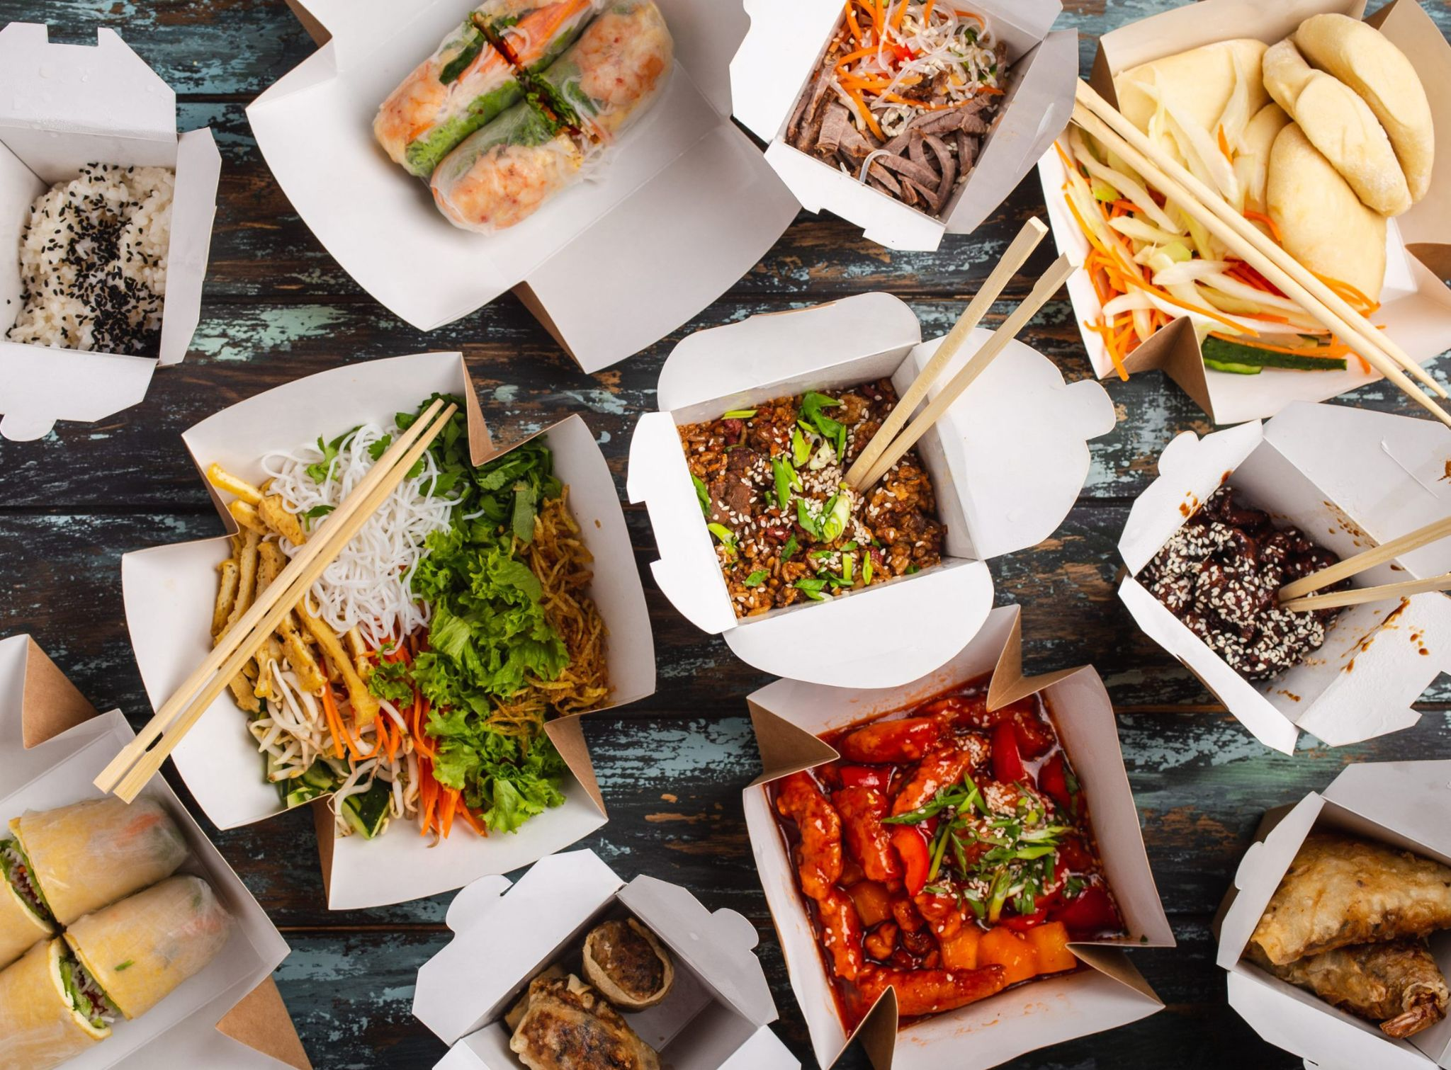

**1.2. Executive Summary:**

In the project, we provide a platform where students can order their desired food from any particular restaurant available in COS market. To achieve the following, we create a software/website on which the user can actually place their favourite order. On clicking the place order button on the website it requests the restaurants for confirmation of order. After the order is successfully placed, we intend to deliver the order through delivery agents for doorstep delivery. Alongside this, online payment as well as COD(cash on delivery) will be supported. Also, in further versions there will be an option for table booking and restaurant & food review system.

**1.3 Problem Statement:**

In this age of technology, where everything is at our fingertips, we often find some grey sections which need better efficiency and technical support. There are apps for food delivery for common citizens and also serve the college students and staff facilities. However in a country like India, most of the restaurants are either shut down by 10p.m. or the hostel residents are not able to get the privilege to order the food due to various restrictions. Also, most of the canteen and the restaurants within the campus are open 24*7, especially during exam times. Along with this, the teachers and staff are not able to go to the COS market due to the completely different atmosphere. To resolve these issues, we are dedicated to create a food delivery platform for the students and staff community and avoid crowds at the restaurants in the pandemic situation and provide contactless deliveries to the students/faculty.

**1.4 Project Business Requirement:**

The project **THUNDER** can be helpful on various business grounds as it provides a platform for students/faculty to order their favourite food. Customers can track their orders on the software. This project serves the pocket of various market sections of the university.This will increase the earning capability of restaurants and delivery agents. Alongside this, other universities and institutes can implement this software in their respective campuses. This idea is yet not capitalized by various renowned food delivery apps. Hence, we wish to explore and capitalize this grey market.

**1.5 Impacts:**

This particular project is made to make an overall impact on various segments :-

**A. Social Impact**

The aim of this project is to help people choose their meals more accurately, by having access to their own choice of restaurants and menus. The online ordering feature may help workers and students order their food online and be a source of livelihood. This application would also help managers to better promote their restaurants.

**B. Technological Impact**

To build this application, new technologies and tools would be used. These technologies are open-source, and will be used to complete the project in the most efficient way.

**C. Environmental Impact**

This application has almost negligible environmental impact.

**D. Economic Impact**

With this application, restaurants may attract more students and staff as its customers, which will increase their revenues. Since the main features of the application are free for both the users and the managers, there is no potential loss for any of them.

**E. Ethical Impact**

Ethically, it is extremely important to secure the application to avoid any data leak. Any new feature should be tested to avoid.

____________________________________________

**2. Assessment of Options:**

**2.1. Financial and Economics Feasibility:**

Being run on a web server, **Thunder** will be hosted on some local systems using Heroku which provides free hosting for a limited traffic and page visits. At the initial stage, the potential market space will be the Thapar Campus(Faculty + Students) and COS market, USP (Unique Selling Point) will be the availability of restaurant services in the COS market and food delivery among its target audience. If the functioning remains smooth and up and running successfully and expanding further, it shall be deployed to cover larger surrounding areas and more number of colleges across various cities, the hosting of which can be managed and funded upon college severs, and hence achieve the target objectives.

The system will follow the Open Source standards for the proper management of the product. No cost will be charged from the users and beneficiaries (i.e, students & teachers).

From these it’s clear that the project Thunder is financially feasible, Keeping in mind all the running costs in the real scenario as well.

**2.2. Technical Feasibility:**

**Thunder** is a web based application. The main technologies and tools associated with Health Connect are:

● HTML

● CSS

● JS

● NODE JS

● Express

● Flutter

● MongoDB

● Firebase

(and other open source packages for some of the future endeavours)

Each of these technologies are freely available and will be used before in the learning stage that we go through before actually starting the project. Time limitations of the product development and the ease of implementation of using these technologies are planned to be balanced.

Initially the web server will be hosted in a free web hosting space with limited hits, and the app will be shared via document and on free app stores.

From above it’s clear that Thunder is technically feasible.

**2.3. Resource & Time Feasibility:**

***Resource feasibility:***

* Programming device (PC / Laptop with enough processing power)
* Hosting space (Heroku for app hosting, mongo / firebase for database hosting)
* IDEs
* Programming individuals (4)

***Time Feasibility:***

As a whole, it’s possible to make an application of the proposed kind in 4 months time by a team of 4 members.

So it’s clear that the **Thunder** has the required resource & time

feasibility.

**2.4 Managerial Feasibility:**

There are already many food order companies right now in the city that do the same work as **Thunder.**

But our idea of **Thunder** app is different from other food delivery companies as it targets only college campuses i.e. shops on campus, students and teachers.

From above it’s clear that Thunder is Managerial feasible.

**2.5 Social and Cultural Feasibility:**

**Thunder** app also provides target audience, delivery agents, faculty, restaurant staff an efficient tool to communicate with each other.

**Thunder** food delivery app works on the sole priority of efficient interaction between these 3 and to fulfil its purpose of providing a handy service, our application ensures social management of all.

From above it’s clear that Thunder app is Social and Cultural feasible.

**2.6. Safety Feasibility:**

Size of database created or used by the product:

Database size will not exceed a certain value as the number of entries/content on every doctor’s page is fixed. Number of doctors will be stored as per the space available but that too upto a certain extent

**Pollution free delivery: Thunder** food app provides the delivery through E-Rickshaws to their customers so that it can be operated safely having minimal adverse effects on the environment.

Number of projected changes to the requirements for the product?

The requirements are clearly identified before the implementation phase. Being a general product (not specific to a single user), the requirements will be changed only if new functionalities are added to the system.

Number of customers who will use this product and the consistency of their needs relative to the product:

Since we have a login credential system for students and teachers the increase in the number of students and teachers viewing the website does not create a problem of space shortage as only the restaurant's admins login consumes space which will always be a substantial amount and will not increase in a sudden manner.

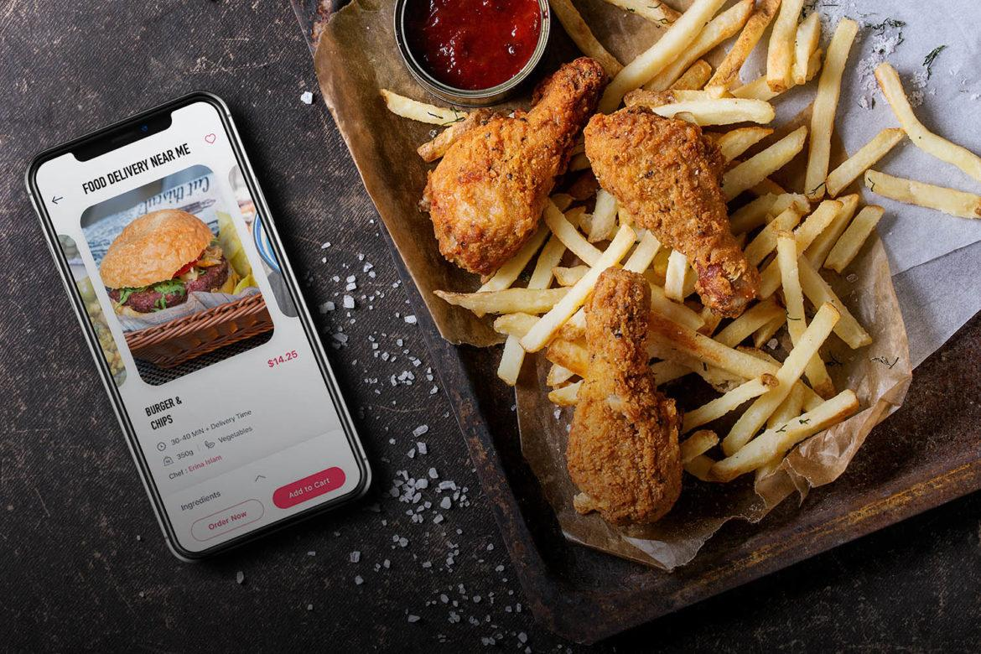

____________________________________________

**3. Risk Assessment of Viable Options**

*To reduce all kinds of risk, the software requirements should be final at the project kick-of .*

**● Scope:** This software aims to deploy the application on the world wide web and to make it **accessible** to everyone. But the project team may not identify all the deliverables when requirements are not properly analysed.

**● Time:** Upon assessment it is found that time risk may get indulged when there is **insufficient resources** to proceed that ultimately leads to insufficient performance and unit testing.

**● Cost:** It is one of the major risks that would require attention in the production model. The software offers a feature-dependent technology, so the final cost will vary in accordance with the **project requirements**.

**● Environment:** The is a web application and could be run on any type of mobile device or a desktop with browser support. The browser must **support JavaScript** applications and cookies.

**● Social & Security:** These include **public security** and the inability of people to participate in the motion. The software aims toward providing a **leakproof** voting system for all the people.

**● Legal:** In the development phase of this application, there are no legal barriers as such but in implementation mode, it would require permissions and **authorization** from the concerned college administration

____________________________________________

**4. Recommended Option for Further Analysis**

● Since the payment gateway requires security testing as well as proper API Request handling, we are not fully aware of all the risks that are associated with the security and scalability of such systems. Implementing payment gateway can bring unknown security risks and vulnerabilities including credit frauds. Payment systems require a more complex design in software and management skills. These critical issues should be discussed in more detail in real payment practices using all the possible options (UPI, Card, Wallets, etc.)

● For this reason, the payment system should be applied to **less clients** and then its scope should be extended. The internet and payment gateway still have many security breaches. Performing the payment and processing it through secure and reliable internet will require significant security and designing advances. Although it may seem like a perfect solution but it is equally important to know the risks associated with the online payment frauds and failures is still possible and is under intensive research.

____________________________________________